AI Harvest Hub: Smart Agriculture Support System using Machine Learning
Pooja L Dematti, Team Members: Pooja M Wandimali, Simran Nadaf, Mohammad Tohid Jamadar
Department of Data Science and AI/ML, ERA Foundation (Internship), Belagavi
Email: poojadematti2018@gmail.com

Abstract: Agriculture faces challenges such as climate change, soil degradation, and market fluctuations that impact productivity. This paper proposes AI Harvest Hub, a smart agriculture system using Artificial Intelligence and Machine Learning for data-driven decision-making. It provides crop recommendation, yield prediction, pest analysis, and fertilizer suggestions using the Random Forest algorithm. The system aims to improve productivity, reduce risks, and promote sustainable farming.
Index Terms: Artificial Intelligence, Machine Learning, Smart Agriculture, Crop Recommendation, Yield Prediction, Sustainable Farming.
INTRODUCTION:
Agriculture is a vital sector that plays a significant role in ensuring food security and supporting economic development, especially in countries like India, where a large portion of the population depends on farming for their livelihood. It contributes significantly to employment, rural development, and national income. However, the agricultural sector is increasingly challenged by factors such as climate change, unpredictable weather conditions, soil degradation, pest infestations, water scarcity, and fluctuating market prices. These challenges directly impact crop productivity, farmer income, and the long-term sustainability of agricultural practices.
In recent years, the impact of climate variability has intensified, leading to irregular rainfall patterns, droughts, floods, and temperature fluctuations. These environmental uncertainties make it difficult for farmers to plan agricultural activities effectively. Additionally, excessive use of chemical fertilizers and improper soil management have degraded soil quality, further reducing crop yield. Pest outbreaks and plant diseases also contribute to significant losses, especially when timely detection and preventive measures are not available.
Traditional farming practices largely depend on experience, intuition, and historical knowledge rather than data-driven approaches. While such practices have been followed for generations, they are often inadequate to address modern agricultural challenges. Farmers frequently struggle to make critical decisions such as selecting suitable crops for specific soil and climatic conditions, estimating expected yield, choosing appropriate fertilizers, and predicting pest outbreaks or market trends. The absence of accurate predictive tools results in inefficient resource utilization, increased risks, and financial losses.
Another major limitation in the current agricultural ecosystem is the fragmentation of available technological solutions. Existing tools and platforms often focus on isolated functionalities, such as weather forecasting, crop recommendation, or soil analysis. This lack of integration forces farmers to rely on multiple sources of information, which can be time-consuming, inconsistent, and difficult to interpret. Moreover, many digital solutions are not user-friendly, limiting their accessibility for farmers with low technical knowledge.
With the advancement of Artificial Intelligence (AI) and Machine Learning (ML), there is a significant opportunity to transform agriculture into a data-driven and intelligent system. Machine learning algorithms can analyze large volumes of agricultural data, identify patterns, and generate accurate predictions that support better decision-making. These technologies enable the development of smart farming systems that improve productivity, optimize resource utilization, and reduce uncertainties.
To address these challenges, this paper proposes AI Harvest Hub, an intelligent agriculture decision-support system that leverages machine learning techniques to provide comprehensive and data-driven recommendations. The system integrates multiple modules, including crop recommendation, yield prediction, drought forecasting, pest risk analysis, fertilizer suggestion, and market price prediction. By combining these functionalities into a unified platform, the system eliminates the need for multiple tools and provides farmers with a holistic solution.
Furthermore, the proposed system incorporates an AI-based insight engine that converts complex model outputs into simple, human-readable explanations and actionable recommendations. This feature enhances usability and ensures that even non-technical users can effectively benefit from the system. The platform is designed to be scalable and adaptable, allowing future integration with IoT devices, real-time weather data, and advanced analytics.
The primary objective of AI Harvest Hub is to enable data-driven agricultural decision-making, improve crop productivity, reduce risks, and promote sustainable farming practices. By bridging the gap between advanced technology and traditional farming, the system aims to empower farmers, enhance their income, and contribute to the overall development of the agricultural sector.
LITERATURE SURVEY:
Several research studies have explored the application of Artificial Intelligence (AI) and Machine Learning (ML) in agriculture to improve productivity and decision-making. A comprehensive survey by Van Klompenburg et al. [1] highlights the effectiveness of machine learning techniques in crop yield prediction, demonstrating their ability to analyze environmental and agricultural data for accurate forecasting. Similarly, Jabed et al. [2] proposed AI-based approaches for yield prediction using soil and weather data, showing improved prediction performance using advanced models.
Research by Kuradusenge et al. [3] emphasizes the effectiveness of machine learning models, particularly the Random Forest algorithm, in predicting crop yield with high accuracy. In addition, Prity et al. [4] developed a crop recommendation system based on soil and climatic conditions, enabling farmers to select suitable crops using data-driven methods.
Several studies have also compared different machine learning algorithms for agricultural applications. Gothane et al. [5] demonstrated that Random Forest outperforms other models in terms of accuracy and reliability. Similarly, Patel et al. [6] compared multiple algorithms, including Support Vector Machine and Neural Networks, and found that ensemble methods provide better performance in crop prediction tasks.
Recent advancements in smart farming systems have focused on improving agricultural productivity through integrated solutions. Dahiphale et al. [7] proposed a machine learning-based smart farming system for crop recommendation, highlighting the importance of automation in agriculture. Another study [8] showed that Random Forest and XGBoost models can achieve high prediction accuracy in yield prediction tasks.
Furthermore, crop recommendation systems using soil and weather data have been widely explored. A study published in IJRASET [9] demonstrated the effectiveness of machine learning techniques in recommending suitable crops. Similarly, Aarthi et al. [10] proposed an AI-based crop recommendation system using soil nutrient and environmental data, improving decision-making for farmers.
Despite these advancements, most existing systems focus on individual agricultural tasks rather than providing an integrated solution. To address this limitation, the proposed AI Harvest Hub system combines multiple predictive modules into a single platform, offering comprehensive decision support for farmers.
PROPOSED SYSTEM:
To address the limitations identified in existing agricultural solutions, this paper proposes AI Harvest Hub, an intelligent and integrated agriculture decision-support system designed to provide data-driven insights for farmers and agricultural stakeholders.
One of the major challenges in current systems is the lack of a unified platform that combines multiple agricultural functionalities. AI Harvest Hub overcomes this limitation by integrating multiple predictive modules into a single system. The platform includes six key modules: crop recommendation, crop yield prediction, drought forecasting, pest risk analysis, fertilizer suggestion, and market price prediction. This integrated approach enables users to access comprehensive agricultural insights from a single interface, improving efficiency and decision-making.
Another important limitation in existing systems is poor accessibility for non-technical users. To address this, the proposed system is designed with a simple and user-friendly interface, making it accessible to farmers with limited technical knowledge. The platform emphasizes ease of use, ensuring that users from rural and semi-urban areas can effectively utilize advanced technologies without requiring specialized skills.
A key feature of the proposed system is the integration of an AI Insight Engine, which enhances the interpretability of machine learning outputs. Instead of presenting complex predictions, the system generates simple, human-readable explanations and actionable recommendations. This improves usability, transparency, and user trust, encouraging wider adoption of the system.
The system utilizes multiple input parameters, including soil data, weather conditions, crop characteristics, and market trends, to generate accurate predictions. Machine learning models based on the Random Forest algorithm are used due to their high accuracy, robustness, and ability to handle large datasets effectively. These models assist farmers in making informed decisions related to crop selection, resource utilization, and risk management.
The platform is implemented using a modern technology stack, with React for the frontend, Flask for backend processing, and Supabase for database management and authentication. This modular architecture ensures scalability, flexibility, and ease of future enhancements, such as integration with IoT devices, real-time data sources, and advanced analytics.
Overall, AI Harvest Hub provides a comprehensive, intelligent, and user-friendly solution that bridges the gap between traditional farming practices and modern data-driven agriculture, aiming to improve productivity, reduce risks, and support sustainable farming.
SYSTEM ARCHITECTURE:
As shown in Fig. 1, the system consists of multiple interconnected components that work together to provide intelligent agricultural decision support. The system begins with the user interface, where farmers or administrators interact with the platform through the frontend developed using React. The frontend collects user input such as soil data, weather conditions, and crop details.
The input data is sent to the backend server, implemented using Flask, which processes user requests and communicates with the machine learning models. The prediction layer consists of multiple models based on the Random Forest algorithm, which generate outputs such as crop recommendation, yield prediction, drought forecasting, pest analysis, and fertilizer suggestions.
The system uses Supabase for database management, where user information, input data, and prediction history are securely stored. The generated predictions are further processed by the AI Insight Engine, which utilizes OpenAI APIs to convert complex outputs into simple, human-readable insights.
Finally, the results are displayed to the user through the dashboard, providing clear recommendations and decision support. This architecture ensures scalability, efficiency, and real-time interaction between system components.

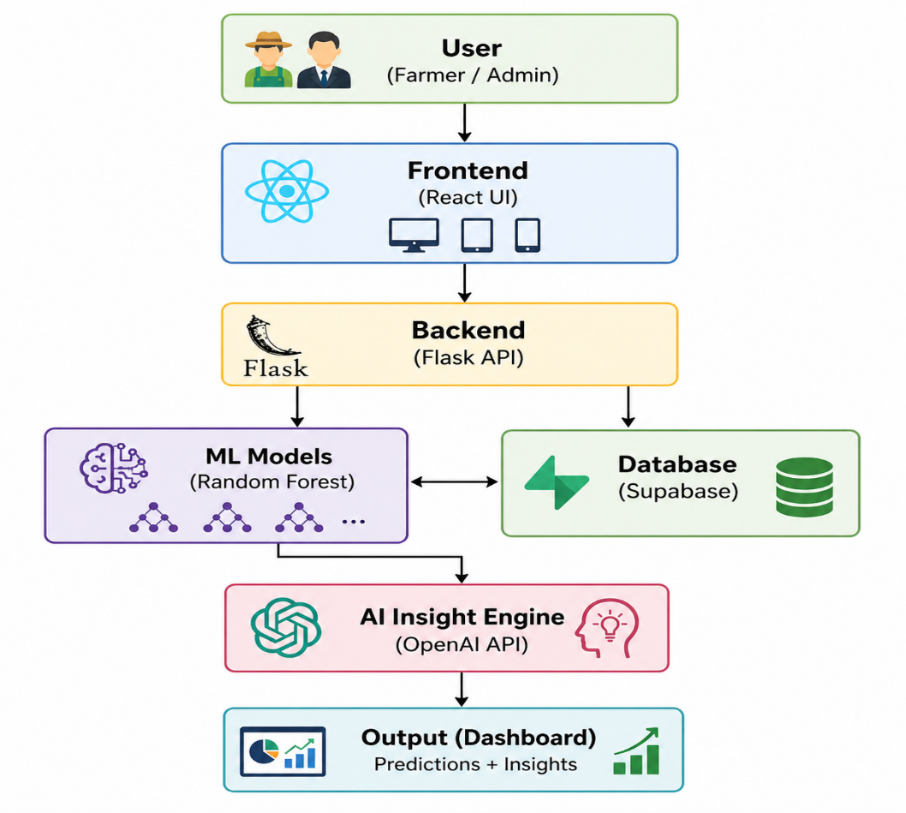
Fig. 1. System Architecture.

METHODOLOGY:
The proposed system follows a structured methodology that includes data collection, data preprocessing, model training, backend development, and system integration to deliver accurate agricultural predictions and recommendations.
Initially, data is collected from multiple reliable sources, including agricultural datasets, weather reports, and market data. These datasets contain important features such as soil nutrients, temperature, rainfall, humidity, crop information, and historical market prices, which are essential for building predictive models.
The collected data undergoes preprocessing to improve quality and ensure consistency. This step includes handling missing values, encoding categorical variables into numerical format, and normalizing data to bring all features to a common scale. Data preprocessing enhances the performance and accuracy of machine learning models.
For prediction tasks, multiple machine learning models are developed using the Random Forest algorithm. Six different models are trained to perform specific agricultural functions, including market price prediction, drought forecasting, crop recommendation, fertilizer suggestion, crop yield prediction, and pest risk analysis. Random Forest is selected due to its robustness, high accuracy, and ability to handle large and complex datasets effectively.
The backend of the system is developed using Flask, which provides RESTful APIs for handling user requests and generating predictions. These APIs process user input data and communicate with the trained machine learning models to produce results.
Finally, the frontend and backend are integrated to create a complete system that delivers real-time predictions and insights to users. This integration ensures seamless communication between the user interface and the machine learning models, enabling efficient and user-friendly access to agricultural recommendations.
SYSTEM WORKFLOW:
The working process is illustrated in Fig. 2 the step-by-step process of data input, processing, prediction, and output generation. The system begins with user authentication, followed by data input related to soil, weather, and crop conditions. The backend processes the input data and forwards it to machine learning models, which generate predictions. The AI Insight Engine converts these predictions into understandable recommendations, which are displayed on the dashboard. Finally, the data is stored in the database for future reference and analysis.
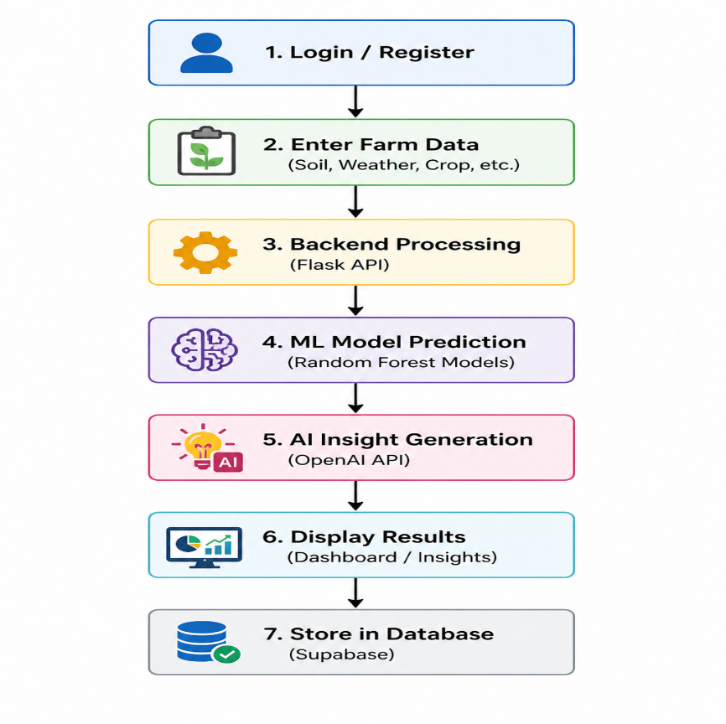
Fig. 2. System Workflow of AI Harvest Hub.
RESULTS AND DISCUSSION:
The proposed AI Harvest Hub system was evaluated using agricultural datasets that include soil nutrients, weather conditions, crop information, and market data. The system successfully generated predictions across its six machine learning modules, providing useful decision-support recommendations for farmers. The developed models were able to identify suitable crops based on environmental conditions, estimate expected crop yield, predict drought risk levels, analyze pest attack risks, suggest appropriate fertilizers, and forecast market price trends.
For instance, when provided with input parameters such as loamy soil, temperature of 28°C, and rainfall of 180 mm, the system recommended rice as the most suitable crop. Similarly, given crop-specific and environmental data, the model predicted crop yield values such as 4.5 tons per hectare for wheat. The system also effectively classified drought risk levels (e.g., moderate risk) based on weather and moisture conditions and generated fertilizer recommendations using soil nutrient values such as nitrogen, phosphorus, and potassium (NPK). These results demonstrate the system’s capability to handle diverse agricultural prediction tasks.
The performance of the system was evaluated using standard metrics. The Random Forest-based models achieved prediction accuracy in the range of 85% to 92%, indicating reliable performance for both classification and regression tasks. The system also demonstrated efficient response time, generating predictions within a few seconds, and achieved a high successful prediction rate of approximately 90%. Additionally, the risk prediction modules showed consistent results across different datasets, highlighting the robustness of the approach. The results confirm that Random Forest is highly suitable for multi-domain agricultural prediction tasks.
The results indicate that AI Harvest Hub effectively addresses real-world agricultural challenges by providing a comprehensive and integrated decision-support system. Unlike traditional farming practices that rely on experience and guesswork, the proposed system enables data-driven decision-making, helping farmers reduce risks associated with drought, pests, and improper resource utilization. The integration of multiple predictive modules into a single platform provides a significant advantage over existing standalone solutions.
Furthermore, the use of the Random Forest algorithm enhances prediction accuracy and model stability, while the AI Insight Engine improves system usability by translating technical outputs into simple, understandable recommendations. This feature makes the system accessible even to non-technical users, thereby increasing its practical applicability.
However, the performance of the system depends on factors such as the quality and completeness of training data, accuracy of input parameters, and environmental variability. In cases where input data is incomplete or inconsistent, prediction accuracy may be affected. Future improvements, including integration with real-time data sources, IoT sensors, and live weather APIs, can further enhance system performance and reliability.
PERFORMANCE OF RANDOM FOREST MODEL ACROSS DIFFERENT MODULES:
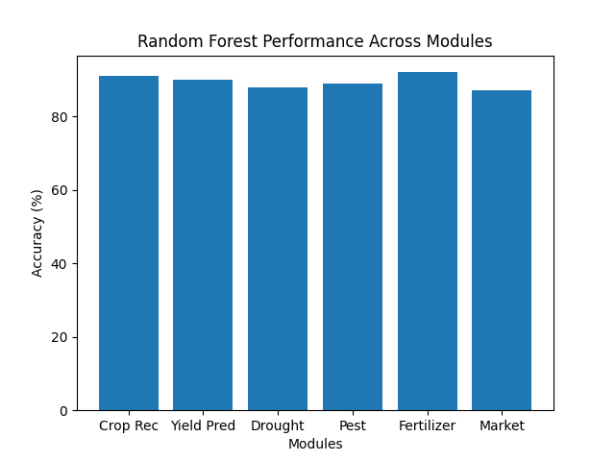
Fig. 3. Performance of Random Forest Model Across Different Modules.
Fig. 3 illustrates the performance of the Random Forest model across different prediction modules in the AI Harvest Hub system. The model achieved high accuracy across all modules, with the highest performance observed in fertilizer suggestion (92%) and crop recommendation (91%). These results demonstrate the effectiveness and reliability of the Random Forest algorithm for diverse agricultural prediction tasks.

CONCLUSION:
The proposed AI Harvest Hub system demonstrates the effective application of Machine Learning and Artificial Intelligence in enhancing agricultural practices. The system integrates multiple predictive modules, including crop recommendation, yield prediction, drought forecasting, pest risk analysis, fertilizer suggestion, and market price prediction, to provide comprehensive decision support.
The use of the Random Forest algorithm ensures high prediction accuracy and reliability, while the AI-based insight engine enhances usability by converting complex outputs into simple and actionable recommendations. This enables farmers to make informed, data-driven decisions instead of relying on traditional methods.
Overall, the proposed system contributes to reducing agricultural risks, improving productivity, and promoting sustainable farming practices. By providing an integrated and user-friendly platform, AI Harvest Hub serves as an effective smart agriculture solution for farmers, agronomists, and other stakeholders.
FUTURE SCOPE:
The proposed AI Harvest Hub system offers significant potential for further enhancements and real-world applicability. While the current system provides accurate predictions using machine learning techniques, it can be extended to improve performance, usability, and scalability.
In future work, the system can be integrated with Internet of Things (IoT) sensors to collect real-time data such as soil moisture, temperature, and humidity directly from agricultural fields. This integration will enable continuous monitoring and improve the accuracy of predictions. Additionally, the development of a mobile application can enhance accessibility, allowing farmers to interact with the system anytime and from any location.
The platform can also be extended by incorporating satellite data and weather APIs to improve drought prediction and crop analysis. Advanced machine learning techniques, including deep learning models, can be explored to further enhance prediction accuracy and model performance. Furthermore, the inclusion of multilingual support will make the system more accessible to farmers from diverse regions.
Additional features such as real-time alerts, voice-based interaction, and integration with government agricultural schemes can further improve the usability and practical impact of the system. These enhancements will contribute to making AI Harvest Hub a more robust, scalable, and farmer-friendly smart agriculture solution.
REFERENCES:
[1] T. van Klompenburg et al., “Crop Yield Prediction Using Machine Learning: A Systematic Literature Review,” Computers and Electronics in Agriculture, 2020.
[2] M. Jabed et al., “Crop Yield Prediction in Agriculture Using AI Techniques,” 2024.
[3] M. Kuradusenge et al., “Crop Yield Prediction Using Machine Learning Models,” Agriculture Journal, 2023.
[4] Prity et al., “A Machine Learning Approach to Crop Recommendation,” Springer, 2024.
[5] Gothane et al., “Crop Yield Prediction Using Random Forest Algorithm,” 2024.
[6] Patel et al., “Machine Learning Algorithms for Crop Recommendation in Precision Agriculture,” 2025.
[7] Dahiphale et al., “Smart Farming: Crop Recommendation Using Machine Learning,” 2025.
[8] “Crop Yield Prediction Using Random Forest and XGBoost,” 2025.
[9] “Crop Recommendation Using Machine Learning Based on Soil and Weather Data,” IJRASET.
[10] Aarthi et al., “AI-Based Smart Crop Recommendation System,” 2025.

